* Firstly,

Showing the Option Panel;

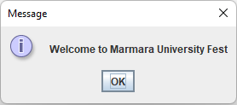

Frame Script:

JOptionPane.*showMessageDialog*(null, "Welcome to Marmara University Fest");

* After clicking the OK button Main Frame appears and we can see two options;

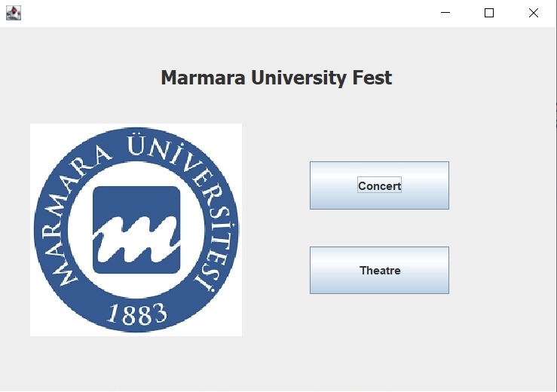

Frame Script:

frame = new JFrame(); *//Create the main frame*frame.setBounds(100, 100, 606, 425);  
frame.setDefaultCloseOperation(JFrame.*EXIT_ON_CLOSE*);  
frame.getContentPane().setLayout(null);  
  
JLabel marmara = new JLabel("Marmara University Fest"); *//Content of frame*marmara.setHorizontalAlignment(SwingConstants.*CENTER*);   
marmara.setFont(new Font("Tahoma", Font.*BOLD*, 20));  
marmara.setBounds(12, 13, 564, 81);  
frame.getContentPane().add(marmara);  
  
ImageIcon img=new ImageIcon("marmara.png");  
JLabel pic=new JLabel(img);  
pic.setBounds(20, 90, 250, 250);  
frame.add(pic);  
  
JButton concert = new JButton("Concert");  
concert.setBounds(330, 143, 148, 51);  
frame.getContentPane().add(concert);  
  
JButton theatre = new JButton("Theatre");  
theatre.setBounds(330, 233, 148, 51);  
frame.getContentPane().add(theatre);

* If we click the “Concert” button, because of the action listener

concert.addActionListener(new ActionListener() {  
 public void actionPerformed(ActionEvent arg0) {  
 ShowEvents shw = new ShowEvents("concert");  
 }  
});

we can see a combo box as regard concert events.

* If we click the “Theatre” button, because of the action listener

theatre.addActionListener(new ActionListener() {  
 public void actionPerformed(ActionEvent arg0) {  
 ShowEvents shw = new ShowEvents("theatre");  
 }  
});

we can see a combo box as regard theatre events.

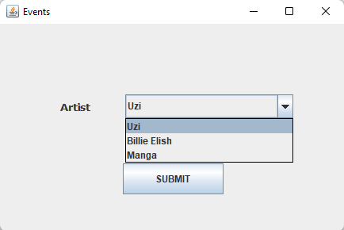 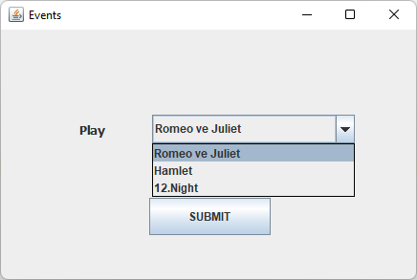

Frame Script:

String concert_list[]= {"Uzi","Billie Elish","Manga"};  
String theatre_list[]= {"Romeo ve Juliet","Hamlet","12.Night"};  
  
public static int *c*;  
private JFrame frame;  
JComboBox<String> jcb;  
String func;  
int a=0,b=0;  
  
private void concert(){  
 jcb=new JComboBox<String>(concert_list);}  
private void theathre(){  
 jcb=new JComboBox<String>(theatre_list);}  
public ShowEvents(String db) {   
 this.func=db; *//Opens concert or theater page* if(func.equalsIgnoreCase("concert")) {  
 concert();  
 a=1;}  
 else {  
 theathre();  
 b=3;}  
 initialize();}

private void initialize() {   
 frame = new JFrame("Events"); *//Creates Events frame* frame.setBounds(100, 100, 450, 300);  
 frame.setDefaultCloseOperation(JFrame.*DISPOSE_ON_CLOSE*);  
 frame.getContentPane().setLayout(null);  
   
 jcb.setBounds(158, 89, 212, 30);  
 frame.getContentPane().add(jcb);  
 if(a==1) {  
 JLabel lblEvents = new JLabel("Artist");  
 lblEvents.setHorizontalAlignment(SwingConstants.*CENTER*);  
 lblEvents.setFont(new Font("Tahoma", Font.*BOLD*, 13));  
 lblEvents.setBounds(45, 92, 101, 27);  
 frame.getContentPane().add(lblEvents);  
 }  
 else {  
 JLabel lblEvents = new JLabel("Play");  
 lblEvents.setHorizontalAlignment(SwingConstants.*CENTER*);  
 lblEvents.setFont(new Font("Tahoma", Font.*BOLD*, 13));  
 lblEvents.setBounds(45, 92, 101, 27);  
 frame.getContentPane().add(lblEvents);  
 }  
   
 JButton btnSubmit = new JButton("SUBMIT");   
 btnSubmit.setBounds(155, 176, 127, 39);  
 frame.getContentPane().add(btnSubmit);  
 frame.setVisible(true);  
}

* If we choose one of events and click the “Submit” button, because of the Action listener

btnSubmit.addActionListener(new ActionListener() {  
 public void actionPerformed(ActionEvent arg0) {  
 *c*=Integer.*valueOf*(EventDetails.*event_ticket*[jcb.getSelectedIndex()+b]);  
 ShowDetails sd = new ShowDetails((String) jcb.getSelectedItem());  
 }  
 });

we can see event details that we choose before.

Concert Events

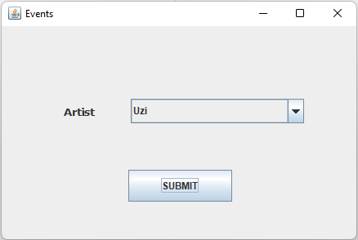

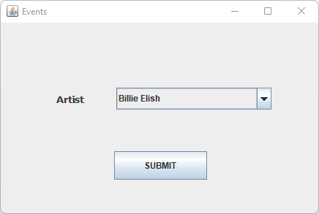

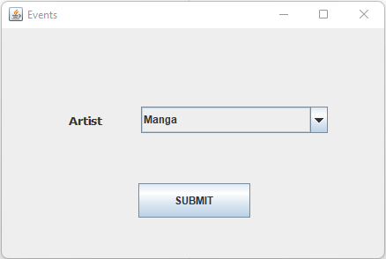

Concert Details

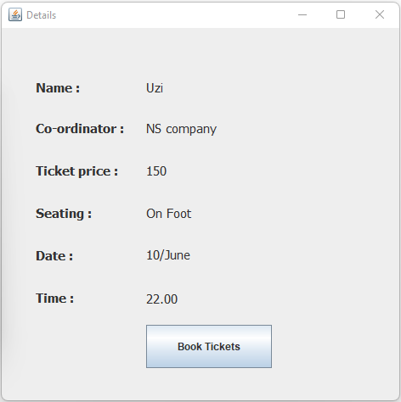

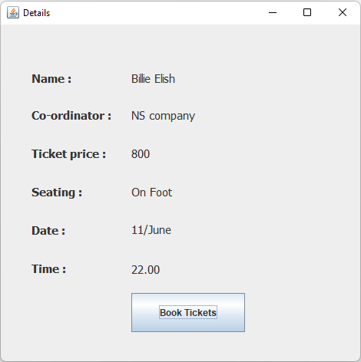

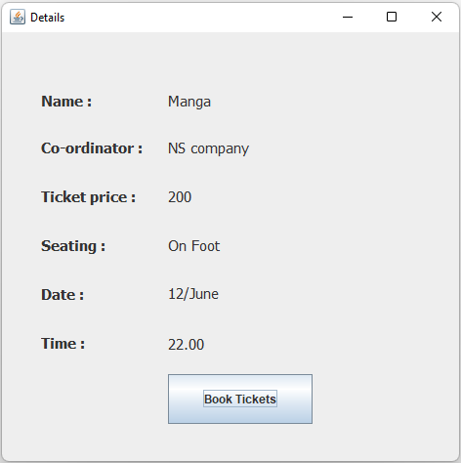

Theatre Events

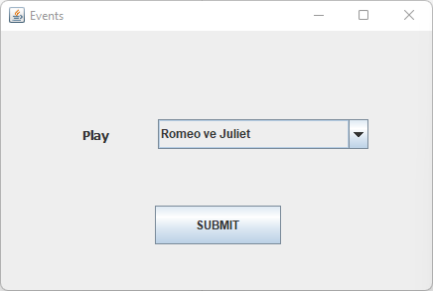

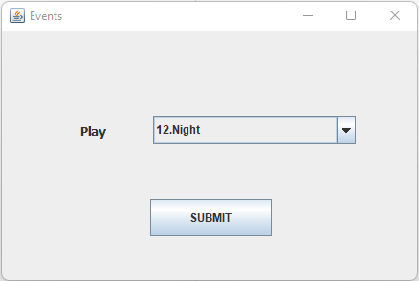

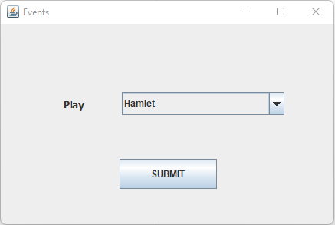

Theatre Details

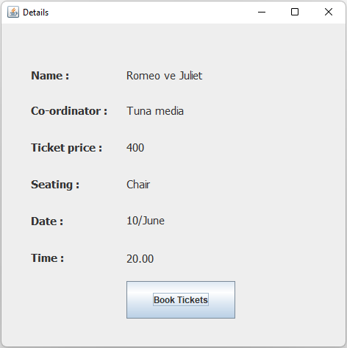

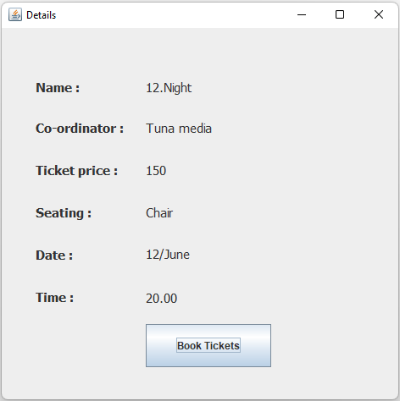

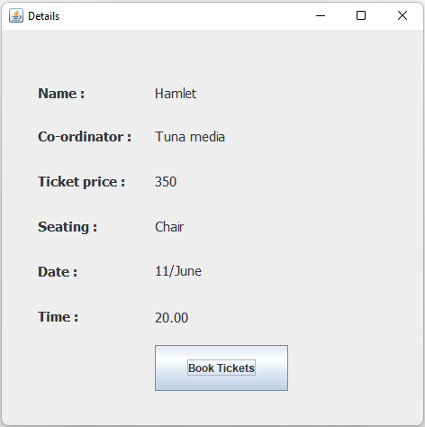

Details frame script:

private void fillDetails(String event)  
{  
 EventDetails ed = new EventDetails(event); *//Taking event details form EventDetails class* lblName_data=new JLabel(ed.name());  
 lblCoordinator_data = new JLabel(ed.coordinator());  
 lblTicket_data = new JLabel(ed.ticket());  
 lblSeating_data = new JLabel(ed.seating());  
 lblDate_data = new JLabel(ed.date());  
 lblTime_data = new JLabel(ed.time());  
   
}  
private void initialize() {  
 frame = new JFrame("Details"); *//Creating Details frame* frame.setBounds(100, 100, 484, 478);  
 frame.setDefaultCloseOperation(JFrame.*DISPOSE_ON_CLOSE*);  
 frame.getContentPane().setLayout(null);  
   
 JLabel lblName = new JLabel("Name :"); *//Content of Details frame* lblName.setFont(new Font("Tahoma", Font.*BOLD*, 15));  
 lblName.setHorizontalAlignment(SwingConstants.*LEFT*);  
 lblName.setBounds(40, 50, 110, 40);  
 frame.getContentPane().add(lblName);  
   
 JLabel lblCoordinator = new JLabel("Co-ordinator :");  
 lblCoordinator.setHorizontalAlignment(SwingConstants.*LEFT*);  
 lblCoordinator.setFont(new Font("Tahoma", Font.*BOLD*, 15));  
 lblCoordinator.setBounds(40, 100, 113, 37);  
 frame.getContentPane().add(lblCoordinator);  
   
 JLabel lblTicket = new JLabel("Ticket price :");  
 lblTicket.setHorizontalAlignment(SwingConstants.*LEFT*);  
 lblTicket.setFont(new Font("Tahoma", Font.*BOLD*, 15));  
 lblTicket.setBounds(40, 150, 113, 37);  
 frame.getContentPane().add(lblTicket);  
   
 JLabel lblSeating = new JLabel("Seating :");  
 lblSeating.setHorizontalAlignment(SwingConstants.*LEFT*);  
 lblSeating.setFont(new Font("Tahoma", Font.*BOLD*, 15));  
 lblSeating.setBounds(40, 200, 130, 37);  
 frame.getContentPane().add(lblSeating);  
   
 JLabel lblDate = new JLabel("Date :");  
 lblDate.setHorizontalAlignment(SwingConstants.*LEFT*);  
 lblDate.setFont(new Font("Tahoma", Font.*BOLD*, 15));  
 lblDate.setBounds(40, 250, 113, 37);  
 frame.getContentPane().add(lblDate);  
   
 JLabel lblTime = new JLabel("Time :");  
 lblTime.setHorizontalAlignment(SwingConstants.*LEFT*);  
 lblTime.setFont(new Font("Tahoma", Font.*BOLD*, 15));  
 lblTime.setBounds(40, 300, 130, 37);  
 frame.getContentPane().add(lblTime);  
   
 lblName_data.setHorizontalAlignment(SwingConstants.*LEFT*);  
 lblName_data.setFont(new Font("Tahoma", Font.*PLAIN*, 15));  
 lblName_data.setBounds(170, 52, 180, 37);  
 frame.getContentPane().add(lblName_data);  
   
 lblCoordinator_data.setHorizontalAlignment(SwingConstants.*LEFT*);  
 lblCoordinator_data.setFont(new Font("Tahoma", Font.*PLAIN*, 15));  
 lblCoordinator_data.setBounds(170, 100, 180, 37);  
 frame.getContentPane().add(lblCoordinator_data);  
   
 lblTicket_data.setHorizontalAlignment(SwingConstants.*LEFT*);  
 lblTicket_data.setFont(new Font("Tahoma", Font.*PLAIN*, 15));  
 lblTicket_data.setBounds(170, 150, 180, 37);  
 frame.getContentPane().add(lblTicket_data);  
   
 lblSeating_data.setHorizontalAlignment(SwingConstants.*LEFT*);  
 lblSeating_data.setFont(new Font("Tahoma", Font.*PLAIN*, 15));  
 lblSeating_data.setBounds(170, 200, 180, 37);  
 frame.getContentPane().add(lblSeating_data);  
   
 lblDate_data.setVerticalAlignment(SwingConstants.*TOP*);  
 lblDate_data.setHorizontalAlignment(SwingConstants.*LEFT*);  
 lblDate_data.setFont(new Font("Tahoma", Font.*PLAIN*, 15));  
 lblDate_data.setBounds(170, 258, 264, 101);  
 frame.getContentPane().add(lblDate_data);  
 frame.setVisible(true);  
   
 lblTime_data.setVerticalAlignment(SwingConstants.*TOP*);  
 lblTime_data.setHorizontalAlignment(SwingConstants.*LEFT*);  
 lblTime_data.setFont(new Font("Tahoma", Font.*PLAIN*, 15));  
 lblTime_data.setBounds(170, 310, 264, 101);  
 frame.getContentPane().add(lblTime_data);  
 frame.setVisible(true);

* Details come from EventDetails.class which defined into a String.

Script:

public class EventDetails {  
 String event_name[]= {"Uzi","Billie Elish","Manga","Romeo ve Juliet","Hamlet","12.Night"};  
 String event_coordinator[]= {"NS company ","NS company","NS company","Tuna media","Tuna media","Tuna media"};  
 static String *event_ticket*[]= {"150","800","200","400","350","150"}; *//static because we are taking the data for price calculations.* String event_seating[]= {"On Foot","On Foot","On Foot","Chair","Chair","Chair"};  
 String event_date[]= {"10/June","11/June","12/June","10/June","11/June","12/June"};  
 String event_time[]= {"22.00","22.00","22.00","20.00","20.00","20.00"};  
 String event;  
 int ind;  
   
   
 EventDetails(String event)  
 {  
 this.event=event;   
 for (int i=0;i<event_name.length;i++) {*//Determine which event is selected* if (event_name[i].equals(event)) {  
 ind = i;  
 break;}  
 }}  
  
 public String name() {  
 return event_name[ind];}  
 public String coordinator(){  
 return event_coordinator[ind];}  
 public String ticket(){  
 return *event_ticket*[ind]; }  
 public String seating() {  
 return event_seating[ind] }  
 public String date(){  
 return event_date[ind];}  
 public String time(){  
 return event_time[ind]; }}

* After monitored the details, if we click the “Book Tickets” button, because of the Action Listener

btnNewButton.addActionListener(new ActionListener() {  
 public void actionPerformed(ActionEvent arg0) {  
 try {  
 TicketSale shw = new TicketSale();  
 } catch (IOException e)   
 e.printStackTrace();  
 }  
 }  
});

we can see other window which is selling ticket.

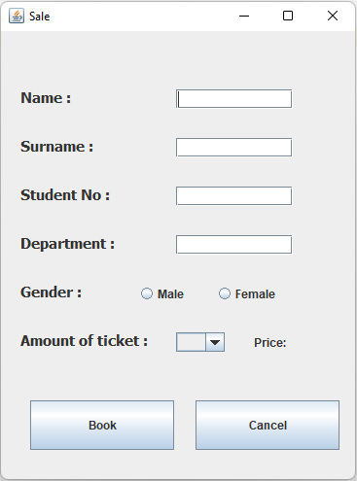

Frame Script:

private JFrame fr,f;  
public TicketSale() throws IOException{  
 frame();}

public void frame() throws IOException {  
 fr = new JFrame("Sale"); *//Crates the Sale frame* fr.setBounds(370, 130, 380, 500);  
 fr.setDefaultCloseOperation(JFrame.*DISPOSE_ON_CLOSE*);  
 fr.getContentPane().setLayout(null);  
 fr.setVisible(true);  
   
 JLabel lblName = new JLabel("Name :"); *//Content of the frame* lblName.setHorizontalAlignment(SwingConstants.*LEFT*);  
 lblName.setFont(new Font("Tahoma", Font.*BOLD*, 15));  
 lblName.setBounds(20, 50, 113, 37);  
 fr.getContentPane().add(lblName);  
   
 JLabel lblSurname = new JLabel("Surname :");  
 lblSurname.setHorizontalAlignment(SwingConstants.*LEFT*);  
 lblSurname.setFont(new Font("Tahoma", Font.*BOLD*, 15));  
 lblSurname.setBounds(20, 100, 113, 37);  
 fr.getContentPane().add(lblSurname);  
   
 JLabel lblStudentNo = new JLabel("Student No :");  
 lblStudentNo.setHorizontalAlignment(SwingConstants.*LEFT*);  
 lblStudentNo.setFont(new Font("Tahoma", Font.*BOLD*, 15));  
 lblStudentNo.setBounds(20, 150, 113, 37);  
 fr.getContentPane().add(lblStudentNo);  
   
 JLabel lblDepartment = new JLabel("Department :");  
 lblDepartment.setHorizontalAlignment(SwingConstants.*LEFT*);  
 lblDepartment.setFont(new Font("Tahoma", Font.*BOLD*, 15));  
 lblDepartment.setBounds(20, 200, 150, 37);  
 fr.getContentPane().add(lblDepartment);  
   
 JLabel lblGender = new JLabel("Gender :");  
 lblGender.setHorizontalAlignment(SwingConstants.*LEFT*);  
 lblGender.setFont(new Font("Tahoma", Font.*BOLD*, 15));  
 lblGender.setBounds(20, 250, 150, 37);  
 fr.getContentPane().add(lblGender);  
   
 JLabel lblTicket = new JLabel("Amount of ticket :");  
 lblTicket.setHorizontalAlignment(SwingConstants.*LEFT*);  
 lblTicket.setFont(new Font("Tahoma", Font.*BOLD*, 15));  
 lblTicket.setBounds(20, 300, 150, 37);  
 fr.getContentPane().add(lblTicket);  
   
 JTextField tName = new JTextField();  
 tName.setHorizontalAlignment(SwingConstants.*LEFT*);  
 tName.setBounds(180, 60, 120, 20);  
 fr.getContentPane().add(tName);  
   
 JTextField tSur = new JTextField();  
 tSur.setHorizontalAlignment(SwingConstants.*LEFT*);  
 tSur.setBounds(180, 110, 120, 20);  
 fr.getContentPane().add(tSur);  
   
 JTextField tNo = new JTextField();  
 tNo.setHorizontalAlignment(SwingConstants.*LEFT*);  
 tNo.setBounds(180, 160, 120, 20);  
 fr.getContentPane().add(tNo);  
   
 JTextField tDepart = new JTextField();  
 tDepart.setHorizontalAlignment(SwingConstants.*LEFT*);  
 tDepart.setBounds(180, 210, 120, 20);  
 fr.getContentPane().add(tDepart);  
   
 JRadioButton gender1=new JRadioButton("Male");  
 JRadioButton gender2=new JRadioButton("Female");  
 ButtonGroup b=new ButtonGroup();  
 b.add(gender1);b.add(gender2);  
 gender1.setBounds(140, 255, 80, 30);  
 gender2.setBounds(220, 255, 80, 30);  
 fr.add(gender1);fr.add(gender2);

* If we click the “Book” button without enter any entries or let any empty space, program gives error which are :

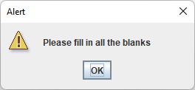

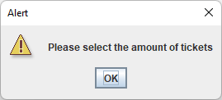

Frame Script:

if(tName.getText().length() == 0 || tSur.getText().length() == 0 ||tNo.getText().length() == 0 ||tDepart.getText().length() == 0) {  
 JOptionPane.*showMessageDialog*(f,"Please fill in all the blanks","Alert",JOptionPane.*WARNING_MESSAGE*);  
}

else if(cb.getSelectedItem()==null){  
 JOptionPane.*showMessageDialog*(f,"Please select the amount of tickets","Alert",JOptionPane.*WARNING_MESSAGE*);  
}

* Also program helps us to calculate the price of events based on amount of tickets and price of events(We choose Uzi concert and 150TL per ticket):

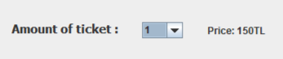

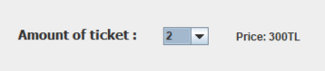

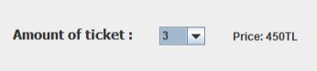

cb.addActionListener(new ActionListener() {

*//Calculates the price based on the amount of the ticket* public void actionPerformed(ActionEvent arg0) {  
 price.setText("Price: "+ShowEvents.*c*\*cb.getSelectedIndex()+"TL");  
 }  
});

* If we fill all the empty spaces properly, program won’t give an error and records the data into the book list.txt (Write)

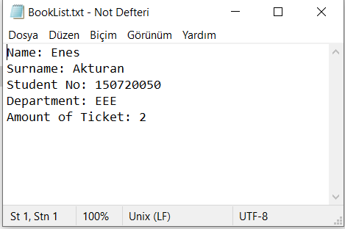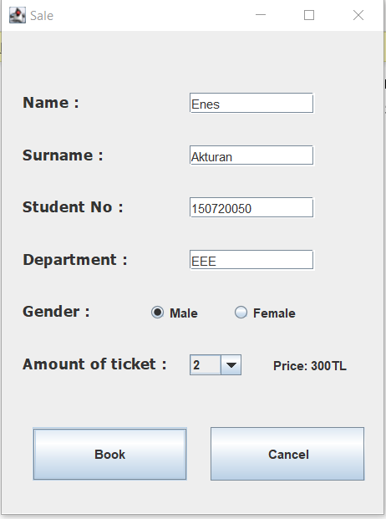

* And continue with the last window:

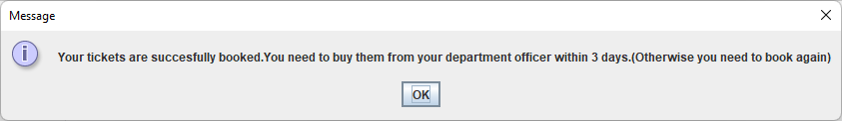

Frame Script:

else { *//If every slot has been filled it gives the info and close the page*

JOptionPane.*showMessageDialog*(f,"Your tickets are succesfully booked.You need to buy them from your department"  
 + " officer within 3 days.(Otherwise you need to book again)");  
fr.dispose();  
}

* After click the “OK” button, program returns detail parts.